MECHANCIAL/ELECTRICAL PERMIT FORM INSTRUCTIONS
READ FIRST: YOU MUST HAVE OR DOWNLOAD THE FREE ADOBE ACROBAT READER DC OR OTHER PDF VIEWER TO HAVE FULL FUNCTIONALITY https://get.adobe.com/reader/otherversions/
THIS FORM IS TO ONLY BE USED AND SUBMITTED ELECTRONICALLY.
ONLY NON-FEE REQUIRED PERMITS ARE ACCEPTED WITH ELECTRONIC SUBMISSION
CALL OUR OFFICE IF YOU ARE UNSURE 203-563-0177
PLEASE FOLLOW THE BELOW STEPS:
- FILL OUT FORM IN ITS ENTIRETY
- BE SURE TO INCLUDE ALL LICENSE AND CONTACT INFORMATION
- FILL IN DETAILED DESCRIPTION OF WORK
- BUILDING PERMIT NUMBER AND GENERAL CONTRACTOR’S NAME
- PRINT, DATE AND SIGN THE PERMIT (SEE BELOW FOR INSTRUCTIONS ON SIGNING)
AFTER YOU COMPLETE AND DIGITALLY SIGN THE PERMIT:
- SAVE THE PERMIT TO YOUR COMPUTER WITH THE ADDRESS OF THE PROJECT
- EMAIL THE PERMIT WITH A COPY OF YOUR LICENSE TO BUILDING@WILTONCT.ORG
ONCE WE REVIEW THE PERMIT, YOU WILL RECEIVE AN EMAIL ACCEPTING THE PERMIT.
REMEMBER – ONLY PERMITS THAT DO NOT REQUIRE A FEE ARE ACCEPTED WITH THIS FORM.
ALL PERMITS THAT HAVE FEES INVOLVED WILL STILL REQUIRE YOU TO FILL THEM OUT IN PERSON WITH THE FORMS LOCATED IN OUR OFFICE/ANNEX LOBBY.
CURRENTLY THIS DIGITAL FORM IS NOT TO BE PRINTED OUT AND USED FOR SUBMISSION BY MAIL OR DROP OFF.
SIGNING THE PERMIT
INDICATE WHICH APPLIES BY CHECKING THE APPROPRIATE BOX BELOW:
CLICK ON THE SECTION LABELED SIGNATURE AT THE BOTTOM OF THE PERMIT AND TYPE YOUR NAME
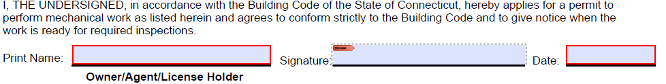
OR YOU CAN CHOOSE THE FILL AND SIGN ICON OR SIMPLY CLICK ON THE BOX AND TYPE YOUR NAME IT WILL DISPLAY AS A SIGNATURE

DRAG YOUR SIGNATURE TO THE SIGNATURE BOX CLICK TO SIDE OF BOX WITHIN THE RED AREA
REMEMBER THESE ARE ONLY FOR DIGITAL SUMBMISSIONS AND PERMITS THAT DO NOT REQUIRE A FEE.

