DEPARTMENT OF  ENVIRONMENTAL AFFAIRS  Telephone (203) 563-0180  Fax (203) 563-0284 | 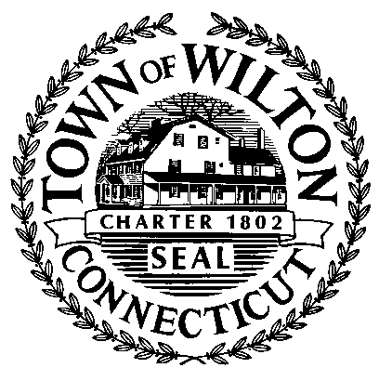 | TOWN HALL  238 Danbury Road  Wilton, Connecticut 06897

PRESS RELEASE
July 26, 2019
Norwalk River Habitat Enhancement Project
Schenck’s Island Open Space – Wilton, CT

The Mianus Chapter of Trout Unlimited, in partnership with the Town of Wilton, Wilton Land Conservation Trust, and Connecticut Department of Energy and Environmental Protection will be conducting a habitat enhancement project along a half-mile stretch of the Norwalk River at Schenck’s Island Open Space this summer.

The current site conditions will be enhanced by creating a narrower and deeper river channel for a variety of habitats for fish and insects. Heavy equipment will be utilized to excavate the stream bed, build channel features and place boulders, which will improve the stream bed stability. Large trees and their root balls will be installed into the riverbank to prevent future erosion and increase bank stabilization.

Trout Unlimited began planning and fundraising for this project over two years ago. They have retained Troutscapes River Restoration to design the project plans and execute the construction work. This company has a proven track record of completing successful river enhancement projects across the United States.
The work is scheduled to begin during the last few weeks of August and is expected to last approximately 10 days. Portions of Schenck’s Island will be closed to the public. However, the trails away from the work zone will be open for public use. The Town encourages residents to explore other parks and open spaces listed on the Conservation Commission’s webpage www.wiltonct.org.

If you have any questions please call Mike Conklin, Director of Environmental Affairs, at (203) 563-0180.

