INLAND WETLANDS  COMMISSION  Telephone (203) 563-0180  Fax (203) 563-0284 | 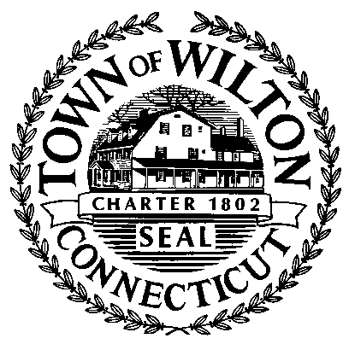 | TOWN HALL  238 Danbury Road  Wilton, Connecticut 06897

LEGAL NOTICE - PUBLISH ONCE

The Wilton Inland Wetlands Commission took the following ACTION on July 14, 2022

GRANTED with conditions, Wetlands Application WET#2808 – MCBRINN – “emergency” septic repair at 43 Sunset Pass, Wilton, CT (Assessor's Map#12, Lot #42).

The full record of the Commission’s action is available for public review at its offices in the Town Hall Annex at 238 Danbury Road, Wilton, CT.

Dated this day 19th of July, 2022 at Wilton, CT
Publish Once in the Wilton Bulletin on July 28, 2022

Penelope Koechl
Secretary

