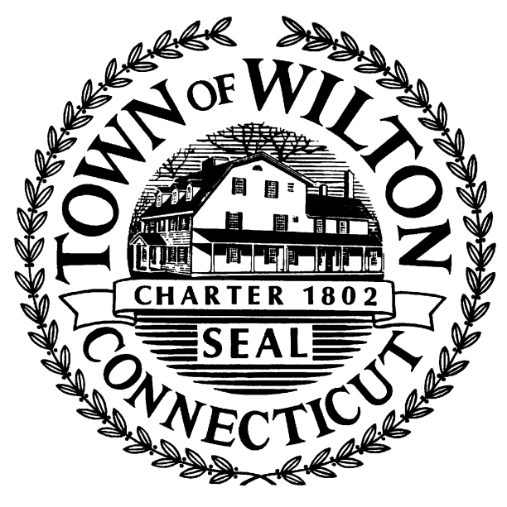
WILTON FIRE COMMISSION
236 Danbury Road
Wilton, CT 06897
203-834-6246

Regular Fire Commission Meeting
May 1, 2019
6:00 PM
Town Hall – Meeting Room B

This meeting has been canceled.

